**Ex.No. : 8b Date:15.03.2025**

**RegisterNo.:221701004 Name:Adhithya A**

SendEmail

# Aim

DevelopanapplicationtoSendEmail.

## Procedure:

**Step1:**File->NewProject

ProvidetheapplicationnameandClick“Next”

**Step2:**Selectthetargetandroiddevices

SelecttheminimumSDKtoruntheapplication.Click“Next”.

**Step3:**Choosetheactivityfortheapplication(Bydefaultchoose“BlankActivity).

Click “Next”.

**Step4:**Enteractivitynameandclick&quot;Finish&quot;.

**Step5:**Edittheprogram.

**Step 6:** Runtheapplication,2-waystorunthe application.

1. Runningthroughemulator
2. Runningthroughmobiledevice

**DepartmentofComputerScienceandDesign**| **RajalakshmiEngineeringCollege**

.

1

## AndroidManifest.xml

*<?xmlversion="1.0"encoding="utf-8"?>*

*<manifest xmlns:android="*[*http://schemas.android.com/apk/res/android"*](http://schemas.android.com/apk/res/android)*xmlns:tools=*[*"http://schemas.android.com/tools*](http://schemas.android.com/tools)*">*

*<application android:allowBackup="true"*

*android:dataExtractionRules="@xml/data_extraction_rules" android:fullBackupContent="@xml/backup_rules" android:icon="@mipmap/ic_launcher" android:label="@string/app_name" android:roundIcon="@mipmap/ic_launcher_round" android:supportsRtl="true" android:theme="@style/Theme.Ex8b"*

*tools:targetApi="31">*

*<activity android:name=".MainActivity" android:exported="true">*

*<intent-filter>*

*<actionandroid:name="android.intent.action.MAIN"/>*

*<categoryandroid:name="android.intent.category.LAUNCHER"/>*

*</intent-filter>*

*</activity>*

*</application>*

*</manifest>*

## Activity_main.xml

<?xmlversion="1.0"encoding="utf-8"?>

<LinearLayout

xmlns:android=["http://sche](http://sche/) mas.android.com/apk/res/a ndroid"

android:layout_width="match_parent"

2

**DepartmentofComputerScienceandDesign**| **RajalakshmiEngineeringCollege**

.

android:layout_height="match_parent"

android:padding="16dp"

android:orientation="vertical">

<EditText

android:id="@+id/editText Email"

android:layout_width="match_parent"

android:layout_height="wrap_content"

android:hint="Recipient Email"

android:inputType="textE mailAddress"/>

<EditText

android:id="@+id/editTextS ubject"

android:layout_width="match_parent"

**DepartmentofComputerScienceandDesign**| **RajalakshmiEngineeringCollege**

.

3

android:layout_height="wrap_content"

android:hint="Subject"/>

<EditText

android:id="@+id/editText Message"

android:layout_width="match_parent"

android:layout_height="wrap_content"

android:hint="Message" android:minLines="5" android:gravity="top"

android:inputType="textM ultiLine"/>

<Button

android:id="@+id/buttonSe nd"

android:layout_width="match_parent"

android:layout_height="wrap_content"

4

**DepartmentofComputerScienceandDesign**| **RajalakshmiEngineeringCollege**

.

android:text="Send Email"

android:layout_marginTop

="16dp"/>

</LinearLayout>

## MainActivity.kt

package com.example.ex8b

import android.content.Intent import android.net.Uri import androidx.appcompat.app

.AppCompatActivity importandroid.os.Bundleimport android.widget.Button import android.widget.EditText import android.widget.Toast

class MainActivity : AppCompatActivity(){

**DepartmentofComputerScienceandDesign**| **RajalakshmiEngineeringCollege**

.

5

private lateinit var editTextEmail: EditText private lateinit var editTextSubject:EditText

privatelateinitvar editTextMessage:

EditText

privatelateinitvar buttonSend: Button

override fun onCreate(savedInstanceS tate: Bundle?) {

super.onCreate(savedInst anceState)

setContentView(R.layout. activity_main)

editTextEmail = findViewById(R.id.editT extEmail)

editTextSubject = findViewById(R.id.editT extSubject)

editTextMessage = findViewById(R.id.editT extMessage)

buttonSend=

6

**DepartmentofComputerScienceandDesign**| **RajalakshmiEngineeringCollege**

.

findViewById(R.id.butto nSend)

buttonSend.setOnClickListener {

sendEmail()

*}*

*}*

privatefun sendEmail(){

val recipient = editTextEmail.text.toStri ng()

val subject = editTextSubject.text.toStr ing()

val message = editTextMessage.text.toSt ring()

if (recipient.isEmpty()|| subject.isEmpty() || message.isEmpty()){

Toast.makeText(this, "Please fill all fields", Toast.LENGTH_SHORT

**DepartmentofComputerScienceandDesign**| **RajalakshmiEngineeringCollege**

.

7

).show()

return

*}*

val intent = Intent(Intent.ACTION_S ENDTO).apply {

data = Uri.parse("mailto:") // only email apps should handle this

putExtra(Intent.EXTRA_ EMAIL,

arrayOf(recipient))

putExtra(Intent.EXTRA_ SUBJECT, subject)

putExtra(Intent.EXTRA_ TEXT, message)

*}*

if (intent.resolveActivity(packageManager)!=null){

startActivity(intent)

}else{

8

**DepartmentofComputerScienceandDesign**| **RajalakshmiEngineeringCollege**

.

Toast.makeText(this,"No email client installed.", Toast.LENGTH_SHORT

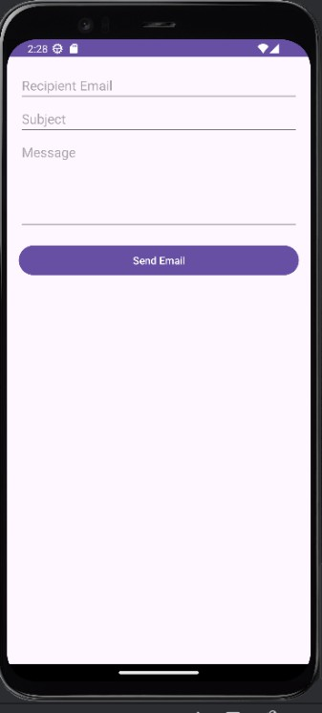

).show()

*}*

*}*

*}*

***Output****:*

# Result:

TheApplicationwasdevelopedusingKotlininAndroidStudio.

**DepartmentofComputerScienceandDesign**| **RajalakshmiEngineeringCollege**

.

9